**Goal**:

By the end of sprint one we will have an application where service posts are possible and a consumer can search through them based on a key term and a location.

**Task listing**:

**User story 0** - “I want to have organized documentation. So that we have a solid base to start our project”

Task 1(1 hour):

* complete sprint plan documentation on google docs

Task 2 (1 hour):

* update the release plan so that it is in line with the sprint plan

Task 3 (1 hour):

* create and update the scrum board on Asana.com

Total: 3 hours

**User story 1** - “As a team member I want to have everyone set up on Github. So that everyone has a foundation to start the project.”

Task 1(1/8 hour):

* clone the repo that the project owner has created

Task 2(1/8 hour):

* Make a commit and push to the repository

Total: .25 hours

**User story 2** - “ As a team we want to design the application page flow. So that we have a good Idea as we are building the application of where it is going”  
Task 1 (.5 hours):

* Group members discuss and diagram ideas for the pages and page flow of the application on paper

Task 2 (.5 hours):

* Finalize the pages and program flow and create a shared document that everyone has access to that shows the pages and application flow

Total: 1 hour

**User story 3** - “As a team we want to design the flow of the interactions between the front and back ends of the project so that all team members have a good idea of the overall structure of the project and how the firebase database interacts with the front end”

Task 1 (.5 hours):

* Discuss as a team how the program flow will happen between the front and back ends of the application. Make diagrams on paper and discuss.

Task 2 (.5 hours):

* Finalize the program flow and document it in a shared space so that all team member can see it and are familiar with it

Total: 1 hour

**User story 4** - “As a service provider I want to be able to sign up and sign in to the app. So that there is security and personalization in the app. And I can contact a service provider once I have signed in.”

Task 1 (2 ideal hours):

* Create a “create account” button on the main sign in page where a user can make an account and determine if the user is a customer or a service provider.

Task 2 (2 ideal hours):

* Create a user sign in page that brings a user to their profile on a successful log in.

Task 3 (1 ideal hour):

* connect to a user database (firebase) that returns the signed in user profile.

Total: 5 ideal hours

**User Story 5** - “I want to create a profile that contains my name, service, rate, pictures and bio so that customers may see them.”

Task 0 ( free / do b4 ):

* Fully specify form fields / database shape.

Task 1 (in combination with task 1: 1 hour):

* create form for filling out info

Task 2 (3 hour):

* Submit form to firebase

Total: 4 hours

**User Story 6** - “As a service provider I want to update my profile. So that provider posts stay current”

Task 1 (1 ideal hours):

* Make a signed in user profile page that includes all alterable fields plus a jobs completed field and a public rating field that are viewable but not alterable.

Task 2 (1 hour - given that user story 3 was done previously):

* Send updated version back to firebase database

Total: 2 hours

**User story 7** - “As a team I want the user interface mockups on figma so that we have something that we will build towards as we do the front end encoding”

Task 1(.5 hours):

* Design the login page

Task 2 (.5 hours):

* Design the main page (with search results of services, a search bar and a tabular navigation bar on the bottom of the page)

Task 3 (.5 hours):

* Design the first page that you would see in the app. This would include a button to sign in or sign up along with the logo of the app.

Task 4 (.5 hours):  
 Design the profile page of a service provider with appropriate fields. (name, service, short bio, rate, jobs completed, public rating)

Total: 2 hours

Total user story hours: 18.25 hours

Spike 1: How to add images to firebase. (1 ideal hour)

Spike 1.5: How to add / update / query firebase documents (2 ideal hours)

Spike 2: How to google auth. (1 ideal hour)

Spike 3: read about MVVM. (Model-View-ViewModel) (.3 hours)

Spike 4: learn SwiftUI basics / best practices / common pitfalls. (3 ideal hours)

Total spike hours: 7 hours

Total hours of ideal work: 26 hours

**Team Roles**:

Dillon: Product Owner

Colton: Scrum Master

Ethan: Developer

Satoki: Developer

Sam: Developer

**Initial task assignment**:

Dillon: 3.1, 4.1, 4.3

Colton: All spikes, Make scrumBoard, finish sprint and release Plan Documentation, Connect to git and commit, Story 5 task 0, 1, 2

Ethan: User Story 4 Task 1, 2

Satokie: User Story 7 task 1, 2, 3

Sam: User Story 4 Task 3

Burnup chart:

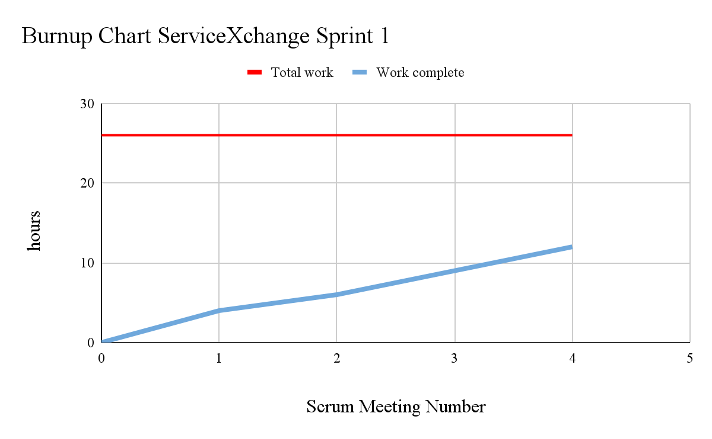

Scrum Board:

Scrum Times:

Monday: 12:00 - 12:15

Wednesday: 12:00 - 12:15

Saturday: 12:00 - 12:15

Backlog:

**User story 4** - “As a consumer I want to be able to search for a specific service”

Task 1 (x hours):

* Create a user interface that prompts users for service provided and desired location.

Task 2 (x hours):

* Make service provided results match what was searched for. (using keyword matching to a service providers post)

Total: x hours

**User story 4** - “As a producer I want a marketplace to advertise my services. ”

Task 1 (x hours):

* Create a post format (condensed to be included in a scrolling search) of a producer's profile page that includes: service provided, name, rate, location, rating, jobs completed, profile picture.

Task 2 (x hours):

* Create user interface where producer posts come up in a scrollable search results page

Total: x hours

**User story 3** - “As a consumer I want to be able to sign into the app and set preferences.”

Task 1 (x hours):

* on the creation of the account prompt the user for a name and a location preference that will be used as the default search area (this field can be altered in search or in the user profile)

Task 2 (x hours):

* add the option for users to include a public profile picture

Task 3 (x hours):

* connect to database in the same way as the producers were connected to the database

Total: x hours